**Testing the Website www.007museum.com**

Home Page not properly displayed

**Used Device/Browser:**

- Chrome (Version 86.0.4240.198 (Official Build) (64-bit)) on Windows 7

**Steps to reproduce:**

- Open the home page <http://www.007museum.com/>

- Scroll down  
- The font will be too big, and the design on the page won’t allow it to be properly displayed

Screenshot:  
  
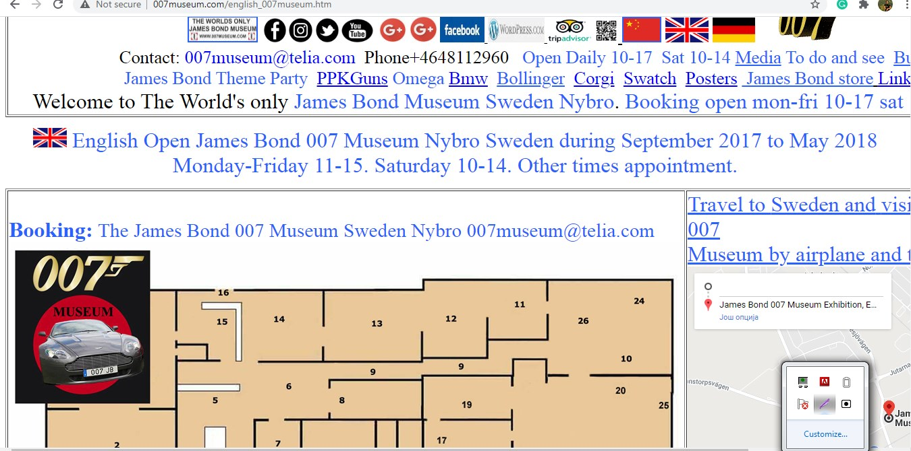

Chinese language selected by default

**Used Device/Browser:**

- Chrome (Version 86.0.4240.198 (Official Build) (64-bit)) on Windows 7

**Steps to reproduce:**

- Open the home page <http://www.007museum.com/>

- In the header, Chinese flag will seem selected by default (due to blue borders around the flag banner), but the default language will be English

Screenshot:

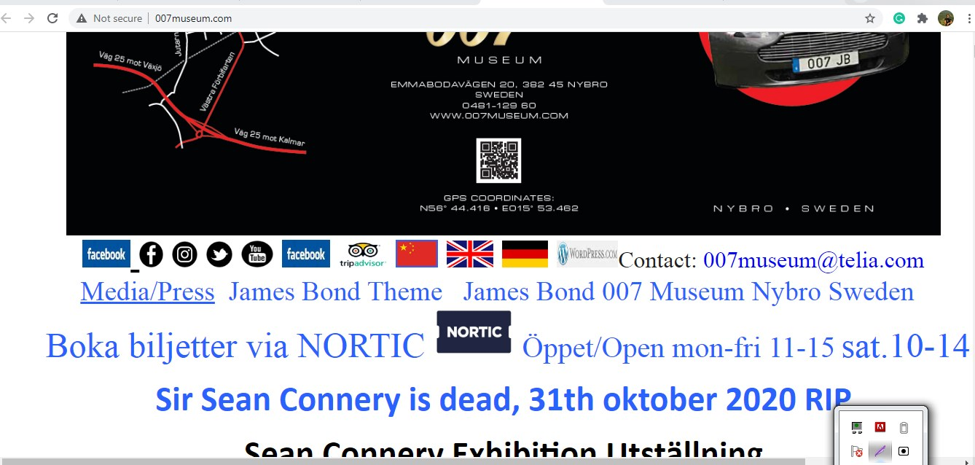

Two languages on the Home Page

**Used Device/Browser:**

- Chrome (Version 86.0.4240.198 (Official Build) (64-bit)) on Windows 7

**Steps to reproduce:**

- Open the home page <http://www.007museum.com/>

- Click on the UK flag in the header to choose English language  
- Scroll down

- There will be English and Swedish on the home page

Screenshot:

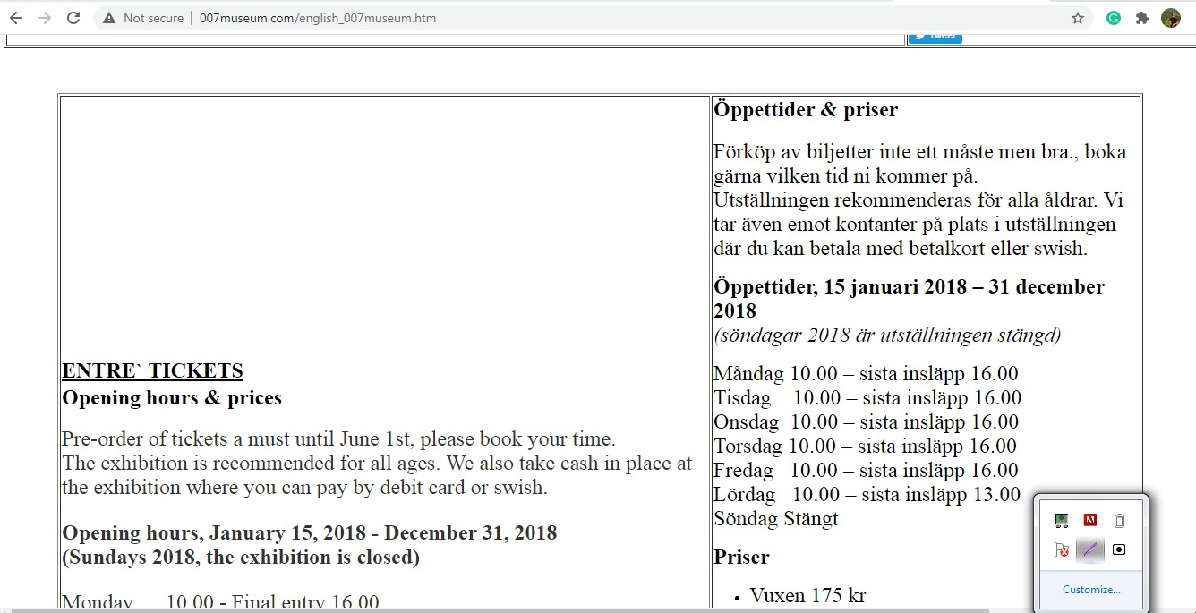

Header doesn’t change language

**Used Device/Browser:**

- Chrome (Version 86.0.4240.198 (Official Build) (64-bit)) on Windows 7

**Steps to reproduce:**

- Open the home page <http://www.007museum.com/>

- Click on the German flag in the header to choose German language  
- Scroll down

- The header will be in English, and the rest of the page will be in German

Screenshot:

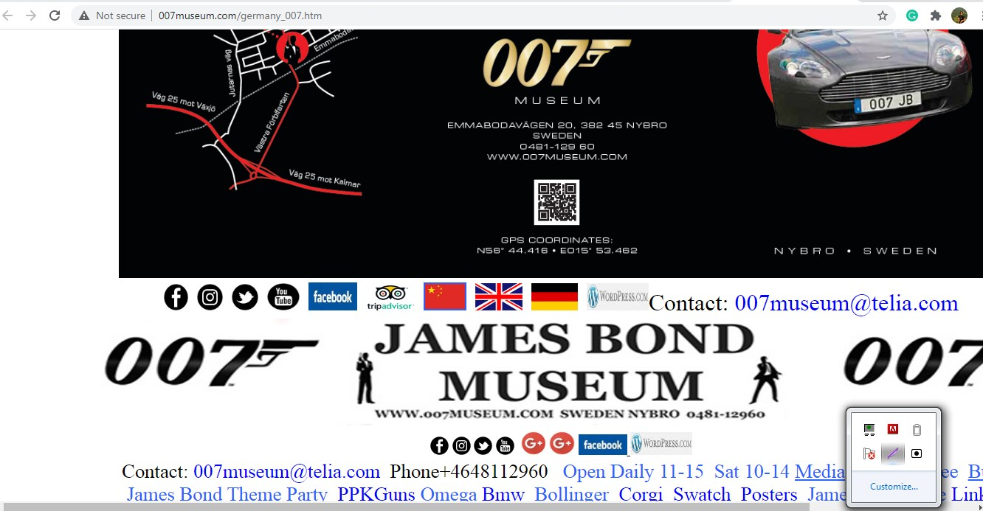

Audio doesn’t play automatically

**Used Device/Browser:**

- Chrome (Version 86.0.4240.198 (Official Build) (64-bit)) on Windows 7

**Steps to reproduce:**

- Open the home page <http://www.007museum.com/>

- Below the Header, click on “Booking: The James Bond 007 Museum Sweden Nybro (or go to <http://www.007museum.com/entre.htm> )

- The audio file called bond-svt-sr.wma will be downloaded, instead of being played automatically.

Screenshot:

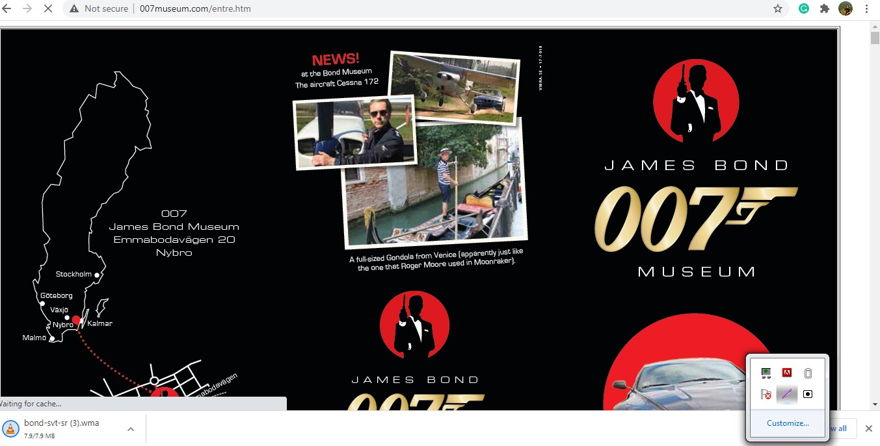

Two Identical Facebook Banners

**Used Device/Browser:**

- Chrome (Version 86.0.4240.198 (Official Build) (64-bit)) on Windows 7

**Steps to reproduce:**

- Open the home page <http://www.007museum.com/>

- In the Header, there will be two Facebook banners, but each leads to a different page, and it might confuse users.

Screenshot:

